Adv. DevOps Exp. 12

Swaraj Patil D15A 40

Step 1: Open the IAM (user)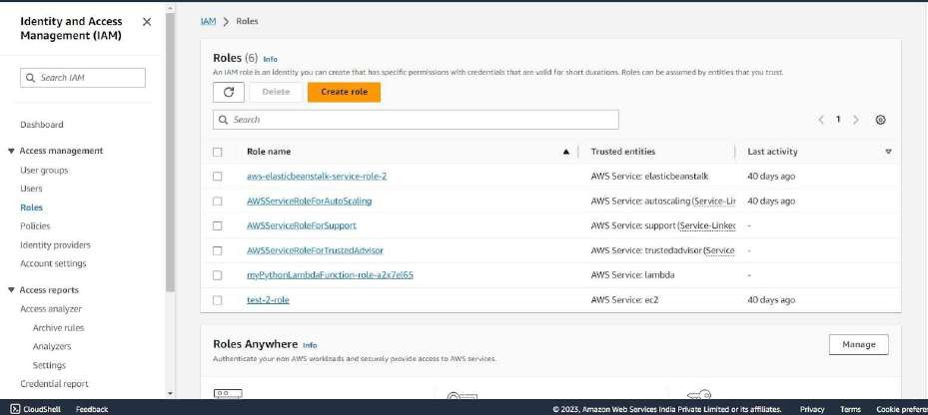

Step 2: Under Attach Policies, add S3-ReadOnly and CloudWatchFull permissions to this role.

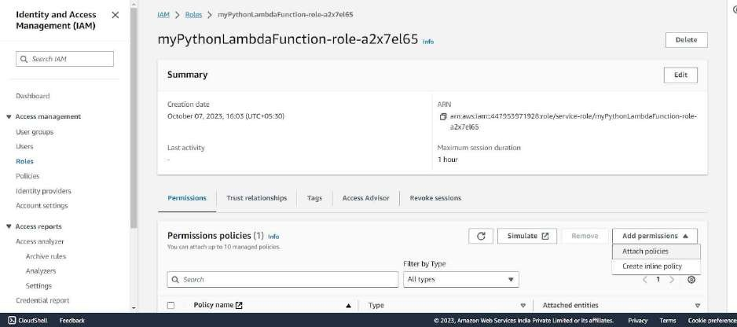

S3-ReadOnly

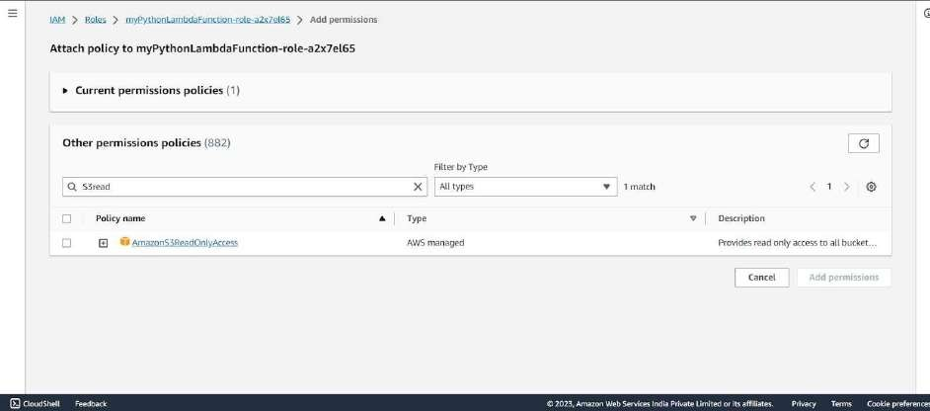

CloudWatchFull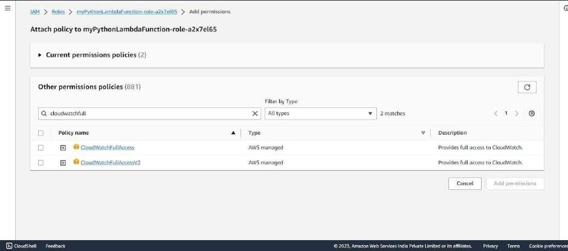

After successful attachment of policy you will see something like this you will beable to see the updated policies.

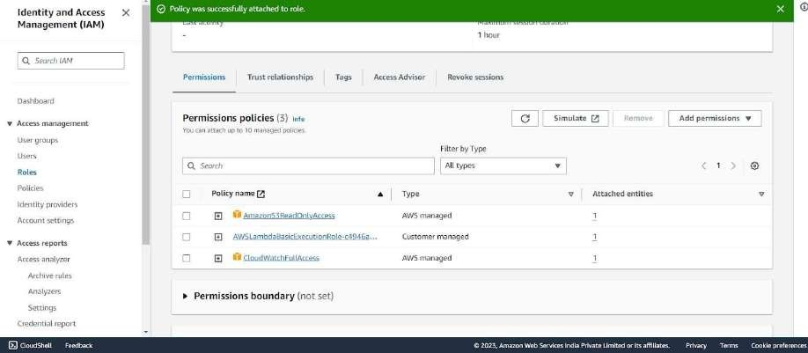

Step 3: Open up AWS Lambda and create a new Python function.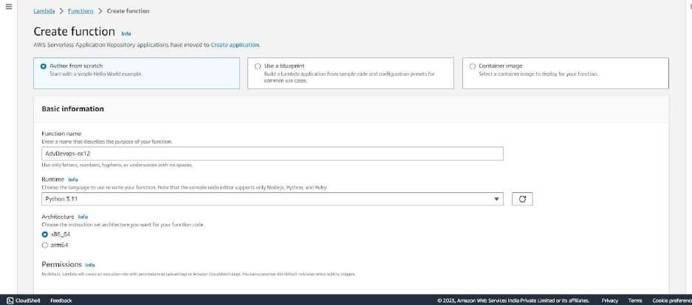

Under Execution Role, choose the existing role, then select the one which was previously created and to which we just added permissions.

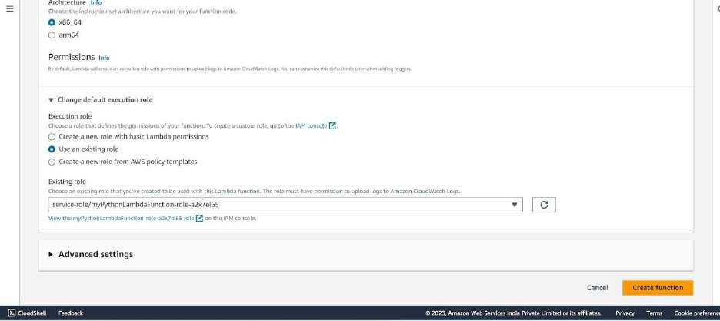

Step 4: The function is up and running.

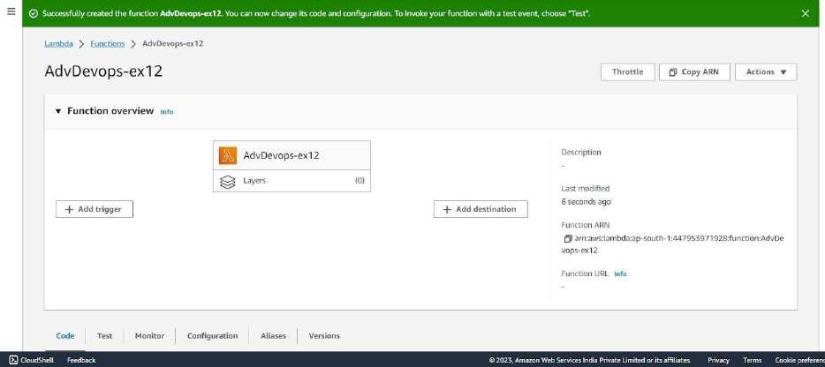

Step 5: Make the following changes to the function and click on the deploy button. This code basically logs a message and logs the contents of a JSON file which is uploaded to an S3 Bucket and then deploy the code.

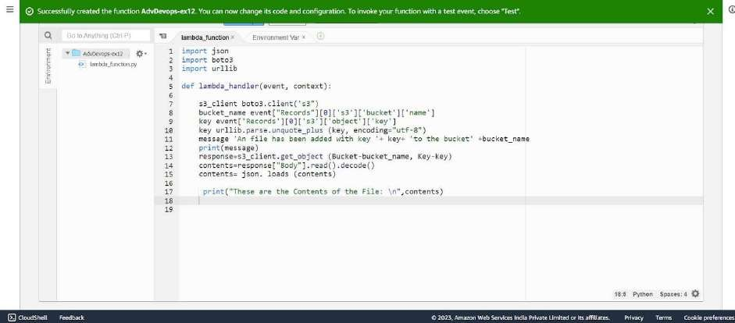

Step 6: Click on Test and choose the ‘S3 Put’ Template.

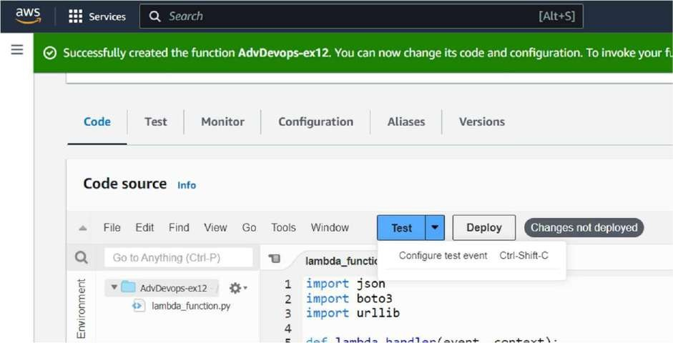

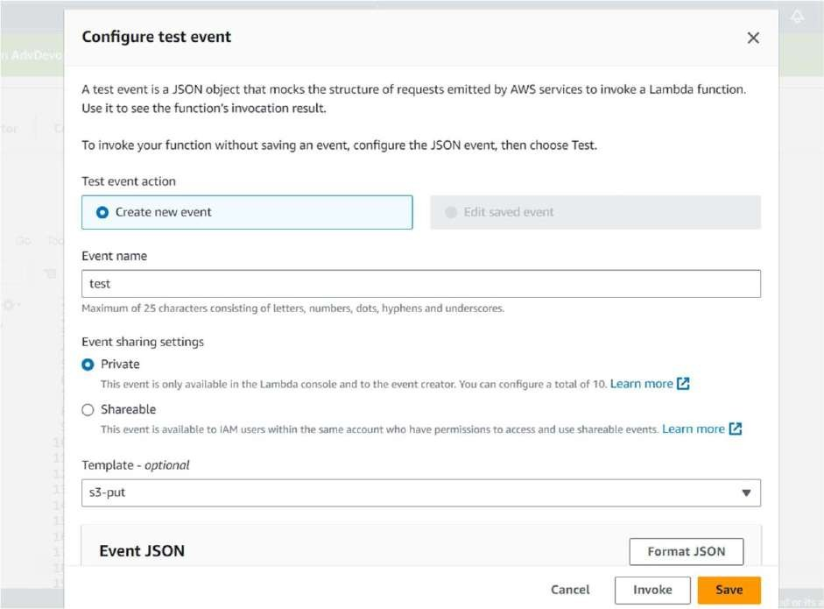

And Save it.

Step 7: Open up the S3 Console and create a new bucket.

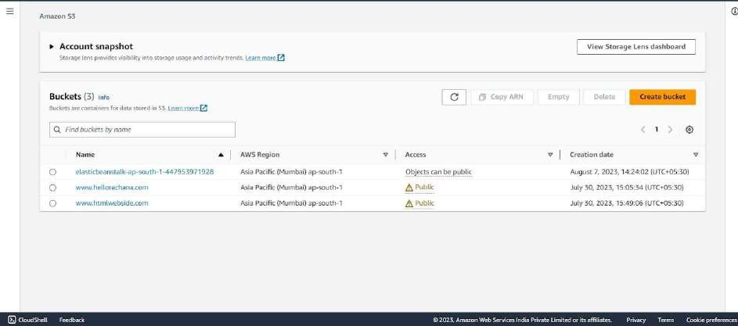

Step 8: With all general settings, create the bucket in the same region as the function.

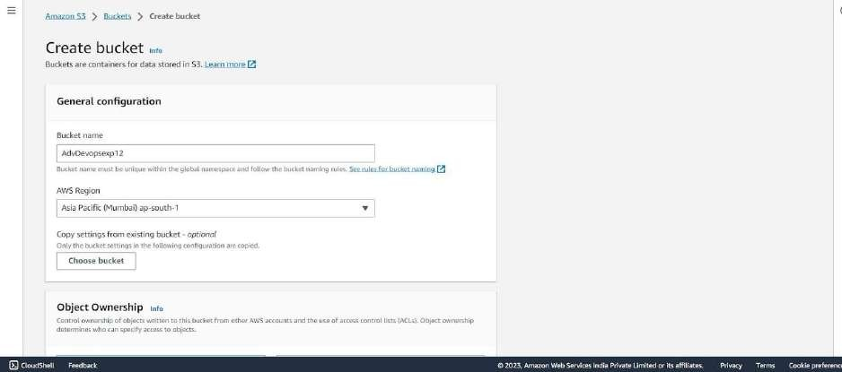

Step 9: Click on the created bucket and under properties, look for events.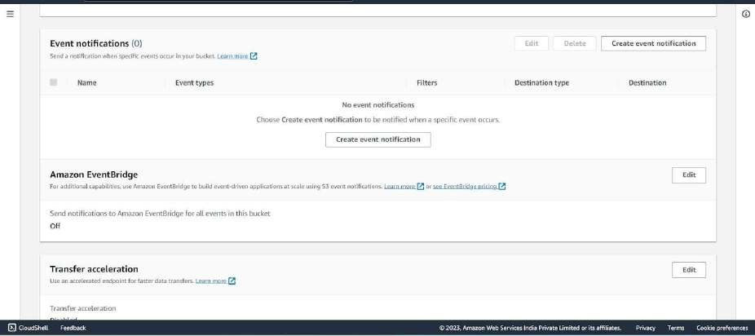

Click on Create Event Notification.

Step 10: Mention an event name and check Put under event types.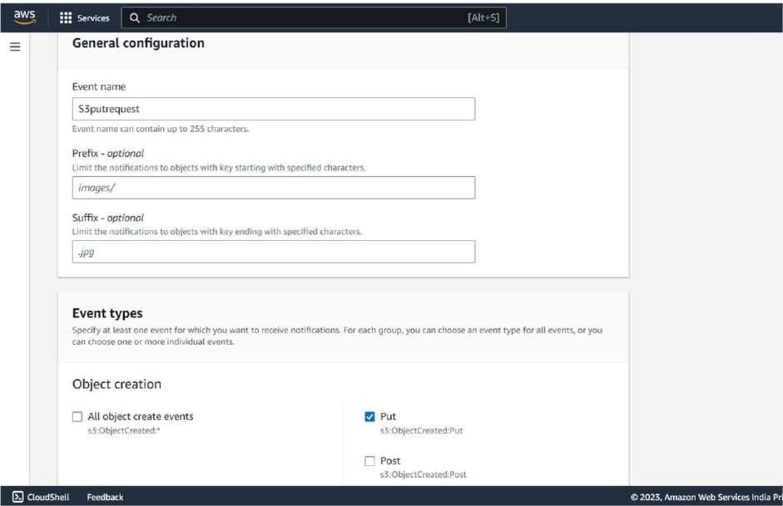

Choose Lambda function as destination and choose your lambda function and savethe changes.

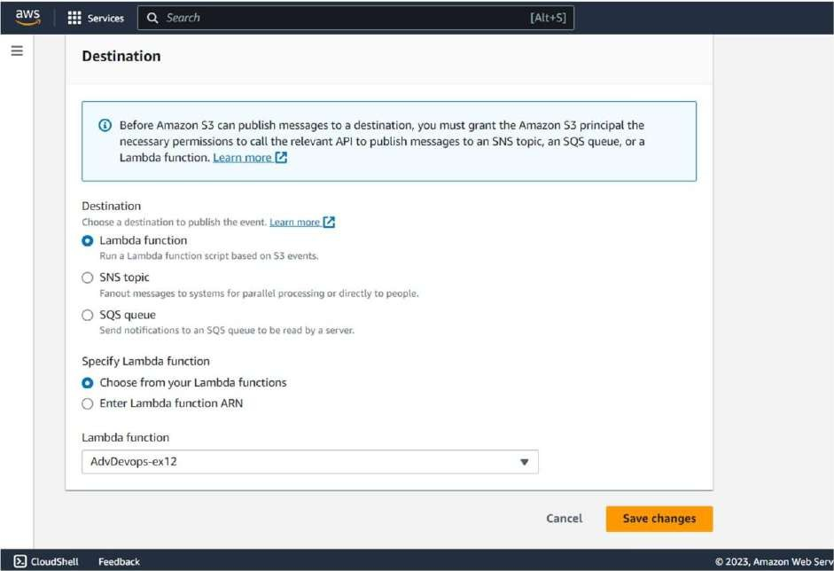

Step 11: Refresh the Lambda function console and you should be able to see an S3 Trigger in the overview.

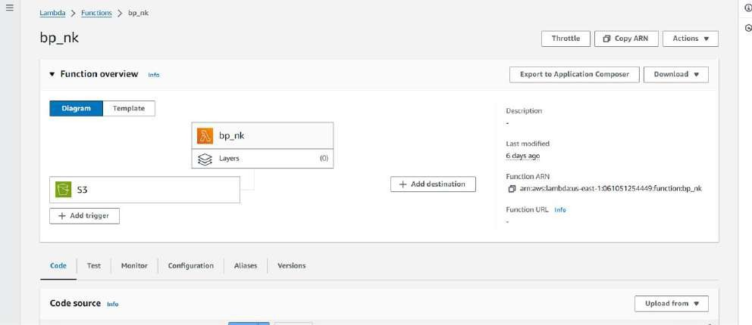

Step 12: Now, create a dummy JSON file locally.

Step 13: Go back to your S3 Bucket and click on Add Files to upload a new file. Step 14: Select the dummy data file from your computer and click Upload.

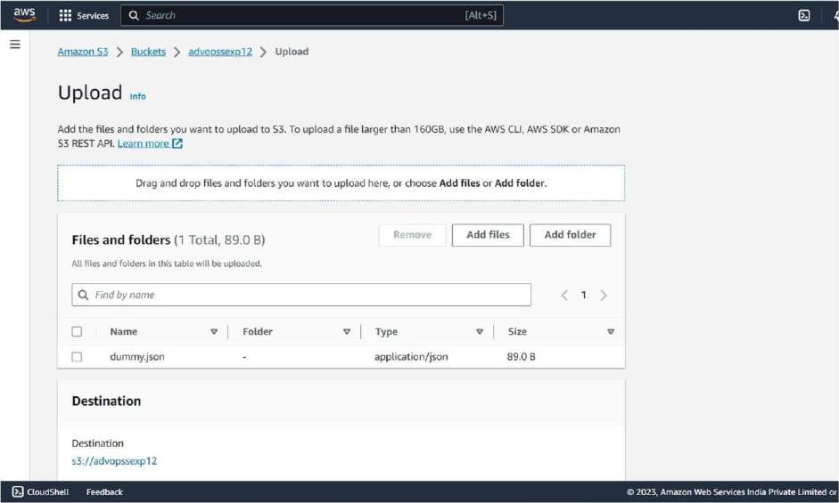

Step 15: After this make the necessary changes in the Test configuration file which we created it previously by replacing the Bucket Name and the ARN of Bucket.

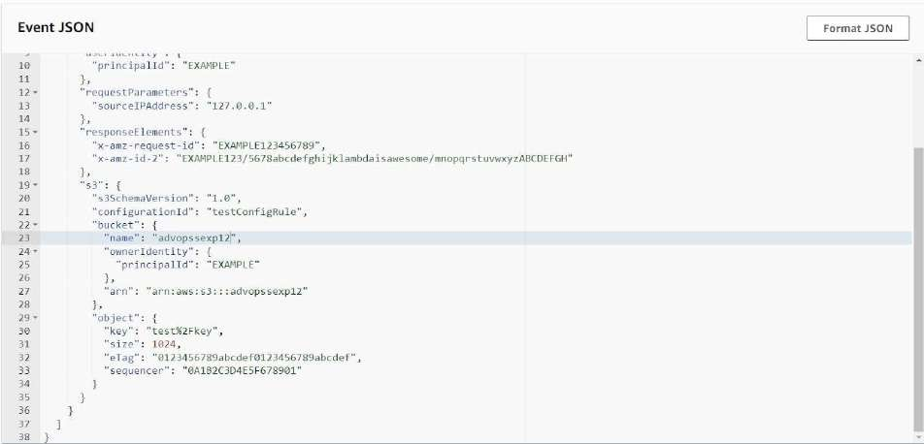

Step 16: Go back to your Lambda function , Refresh it and check the Monitor tab.

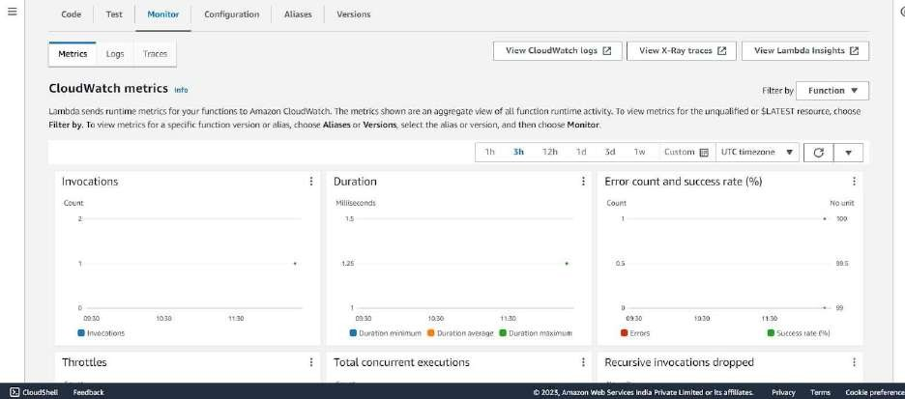

Under Log streams, click on View logs in Cloudwatch to check the Function logs.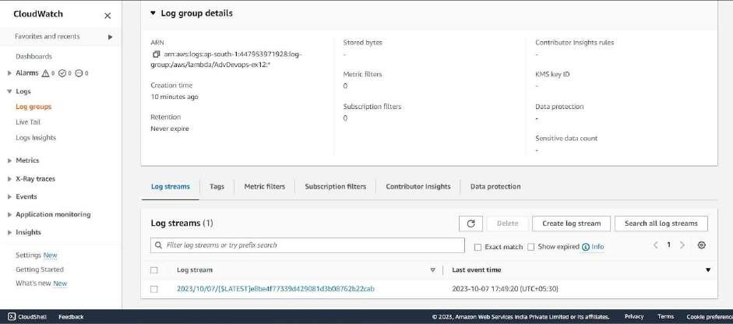

Step 17: Click on this log Stream that was created to view what was logged by your function.

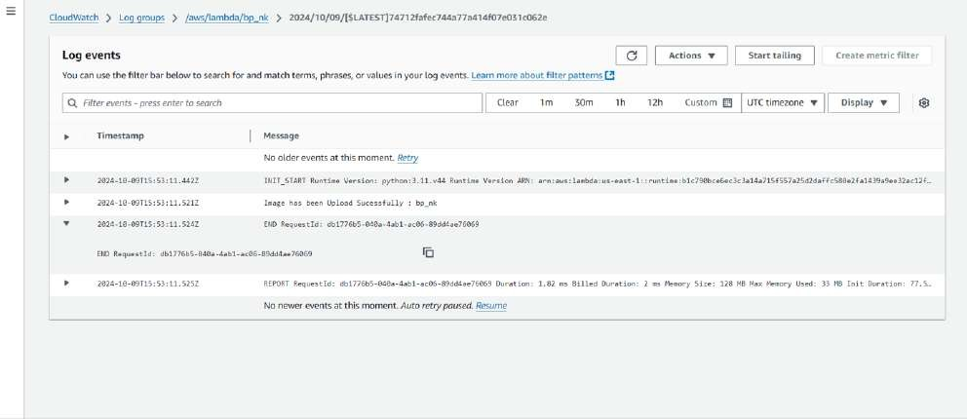

**Conclusion:** Thus, we have created a Lambda function which logs “An Image has been added”

once you add an object to a specific bucket in S3.